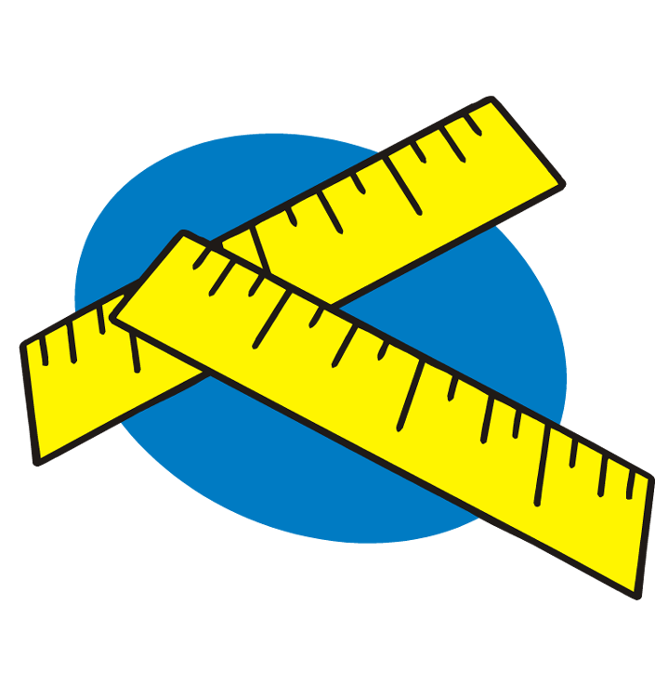
Name ____________________________

The International System of Units

I. The International System of Units

A. If everyone is to understand what your measurements mean, you must agree on the units that will be used.
B. By international agreement, a set of units called ______________________

____________________ has been defined for scientific work. This system was adopted in _______ by the General Conference on Weights and Measures.

C. These units are also called:

D. SI has seven base units:

Quantity | Unit Name | Unit Abbreviation
Length

Mass

Time

Temperature

Amount of
substance
Electric current

Luminous
Intensity

E. Advantages of Using SI
1.

2.

3.
Copyright © May 2013 Amy Brown (aka Science Stuff)
F. SI Prefixes

1. Prefixes can be placed in front of the base units. These prefixes are used to represent quantities that are larger or smaller than the base units.

2. These prefixes must be memorized.

PREFIX | UNIT ABBREVIATION | MEANING
giga
mega
kilo
hecto
deca
deci
centi
milli
micro
nano

G. Equivalents:

1 Gm =
1 Mm =
1 km =
1 hm =
1 dam =

1 meter = _______ dm
1 meter = _______ cm
1 meter = _______ mm
1 meter = _______ μm
1 meter = _______nm

Copyright © May 2013 Amy Brown (aka Science Stuff)
II. Units used in measuring length, mass and volume

A. Length
1. The ______________ is the SI base unit of length.
2. Prefixes are used to indicate distances longer and shorter than a meter.
3. What name and unit is given to each of the following units of length?

a) .000001 m

b) .001 m

c) .01 m

d) .1 m

e) 10 m

f) 1000 m

B. Volume
1. Volume:

2. The cubic meter (m³) is the SI derived unit for measuring volume.
3. When chemists measure the volumes of liquids and gases, they often use a non-SI unit called the _____________.
4. The two units, _________________, are interchangeable.

C. Mass

1. Mass:

2. Weight:

3. Mass and weight are often confused. Mass is not affected by gravitational pull. Your weight on the moon would be less, but your mass on the moon would be the same.
3. The _______________ is the SI base unit for measuring mass.

Copyright © May 2013 Amy Brown (aka Science Stuff)
III. Practice Problems

A. Give the name and symbol for each of the following units:
1. A time that is 100 times as great as 1 second =

2. A length that is 1/1000 the length of 1 meter =

3. A mass that is 1000 times as great as 1 gram =

4. A mass that is 1/1,000,000 the mass of 1 gram =

B. State the quantity that is measured by each of the following units:
1. centigram

2. millimeter

3. Kelvin

4. millisecond

C. How large is:
1. a kilogram, compared with a gram?

2. a millimeter, compared with a meter?

3. a centimeter, compared with a meter?

4. a nanogram, compared with a gram?

5. a decameter, compared with a meter?

IV. Metric Conversions Using Dimensional Analysis

A. An important skill to learn in this class is how to solve a variety of problems. I am going to show you a process called “Dimensional Analysis” that we will use to solve problems in this class all year long. We will apply this process of dimensional analysis to the conversion between the different metric units.

B. “Conversion factors” are:

Copyright © May 2013 Amy Brown (aka Science Stuff)
C. Conversion factors are formed from equalities that state a relationship between two units.

For example:

D. When conversion factors are used properly, all units will divide out (or cancel out) EXCEPT the unit being converted to.

E. For example: How many kilometers are equal to 250 meters?

1. When solving a problem using dimensional analysis, start with what you are given in the problem. (In the above example, 250 m)
2. Decide what conversion factor should be used in the next step.
3. In the conversion factor step, place the unit on bottom that will cancel the unit in the previous step. (Meters went on bottom in the second step in order to cancel out the meter unit.
4. Proceed until you are left with the unit you are looking for.

V. Practice Problems

1. Convert .044 km to meters

2. Convert 4.6 mg to grams

3. Convert 696 cm³ to m³

Copyright © May 2013 Amy Brown (aka Science Stuff)
4. How many seconds are in .079 years?

5. Convert .065 km to dm

6. The density of manganese is 7.21 g/cm³. What is the density in kg/m³?

7. Convert 0.44 mL/min to microliters/sec

8. There are 7 x 10⁶ red blood cells in 1.0 mm³ of blood. How many red blood cells are in one liter of blood?

Copyright © May 2013 Amy Brown (aka Science Stuff)

